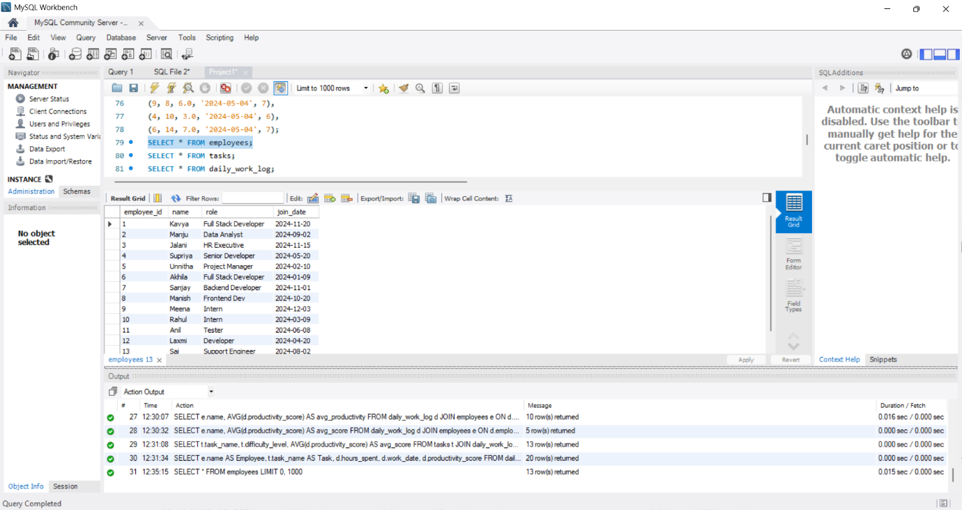
Figure1 - SQL query to display all records from Employee table

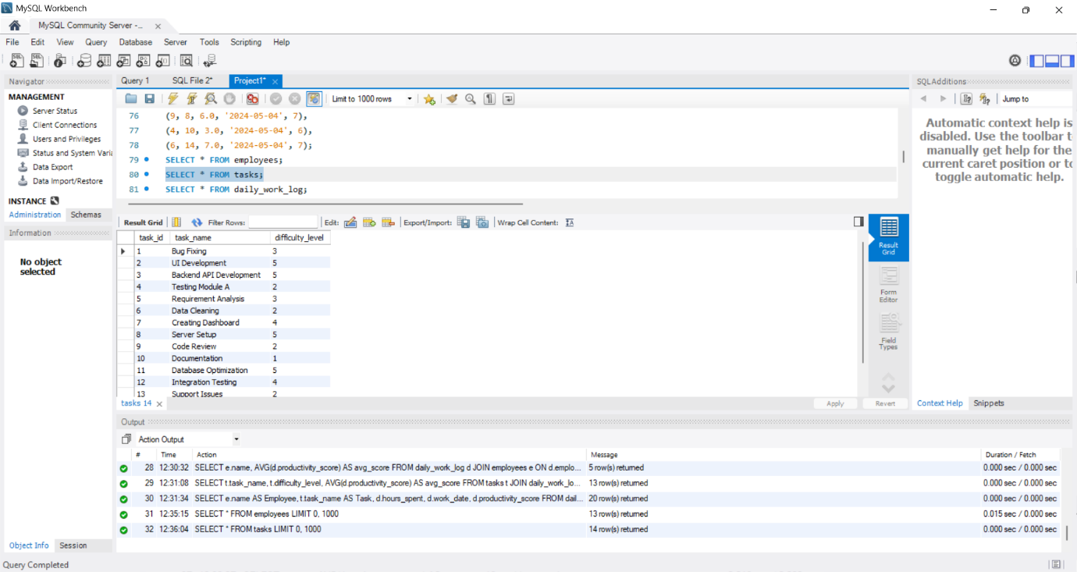
Figure2 - SQL query to display all records from tasks table
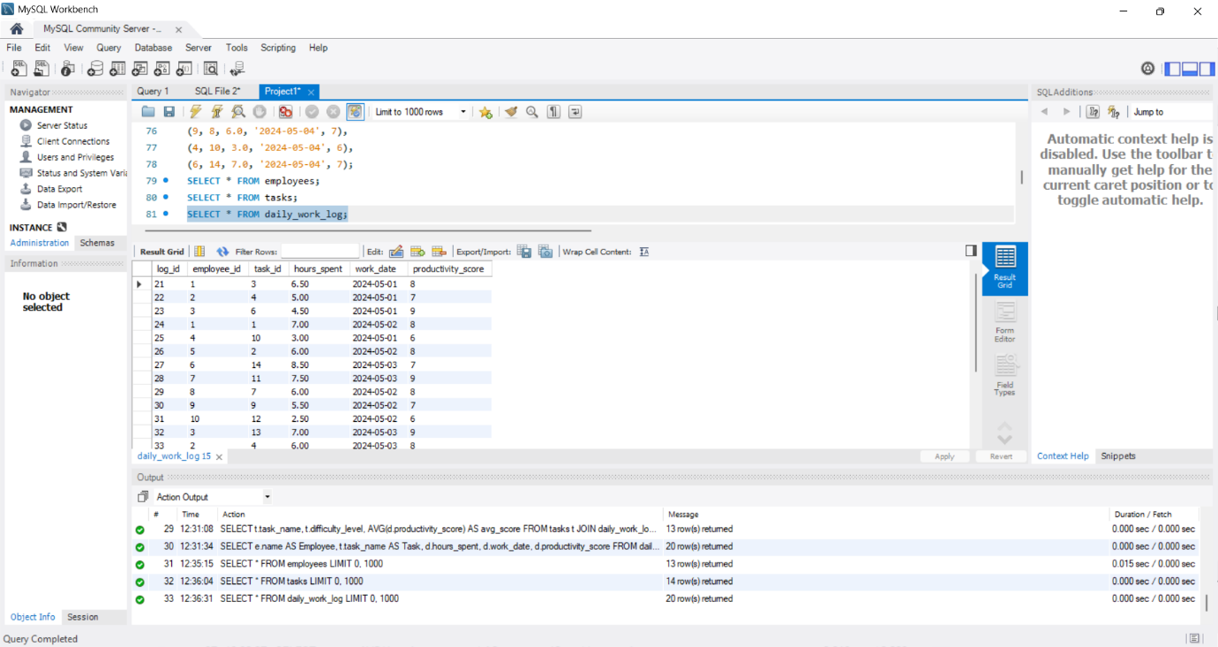
Figure3 - SQL query to display all records from daily_work_log
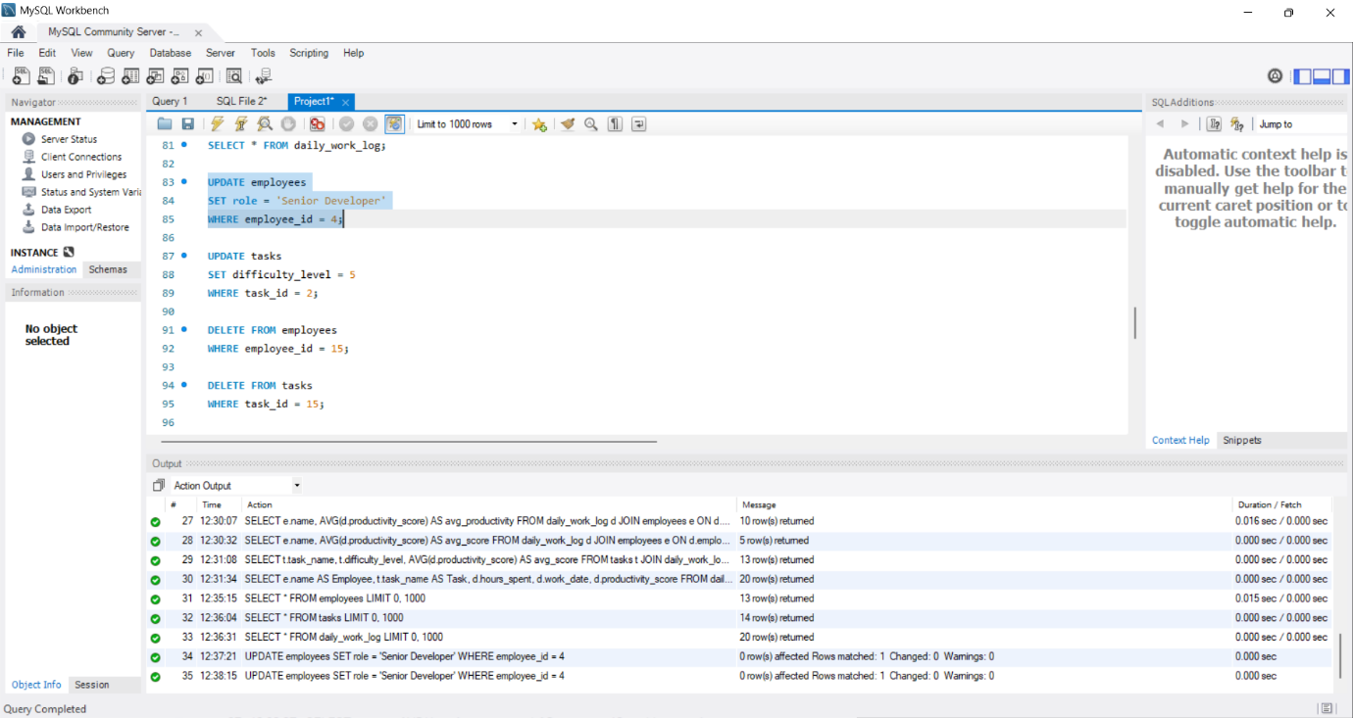
Figure4 - Modify employee information using SQL UPDATE
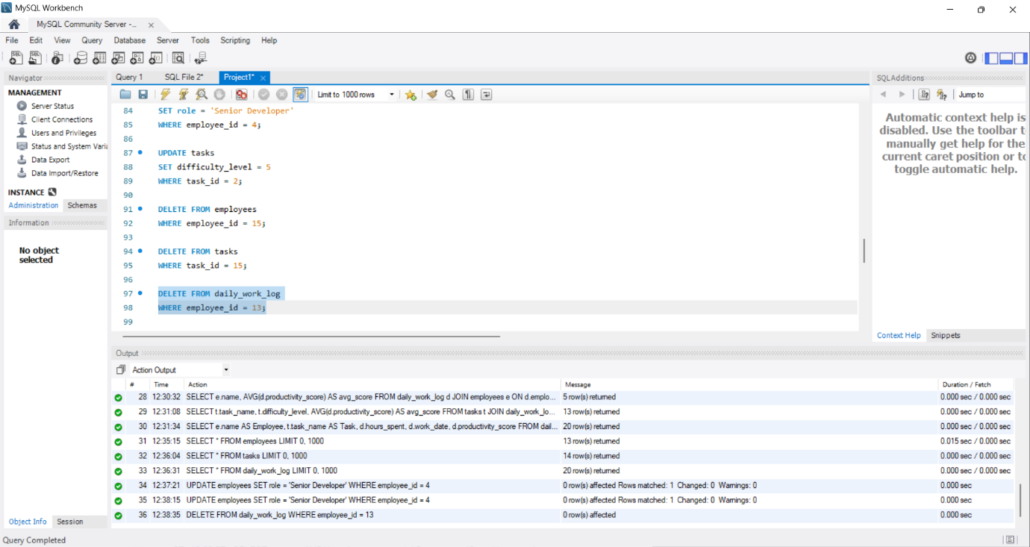
Figure5 - Modify employee information using SQL DELETE
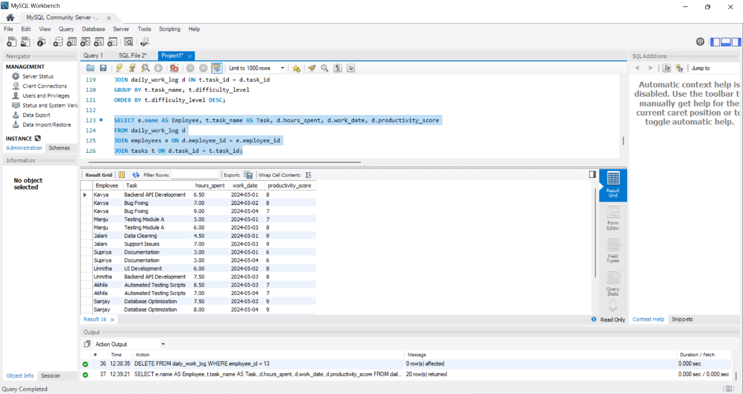
Figure6 - Fetch employee task details along with hours worked and productivity score
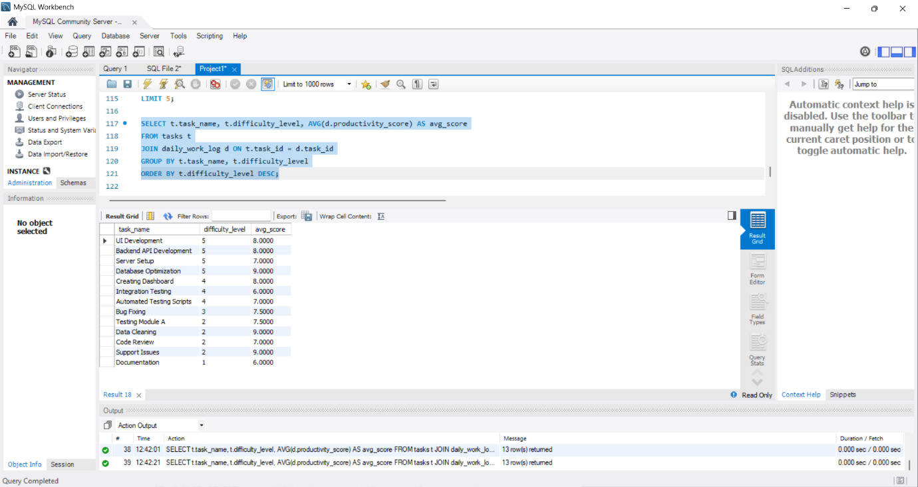
Figure7 - Overview of tasks, their difficulty, and average performance scores
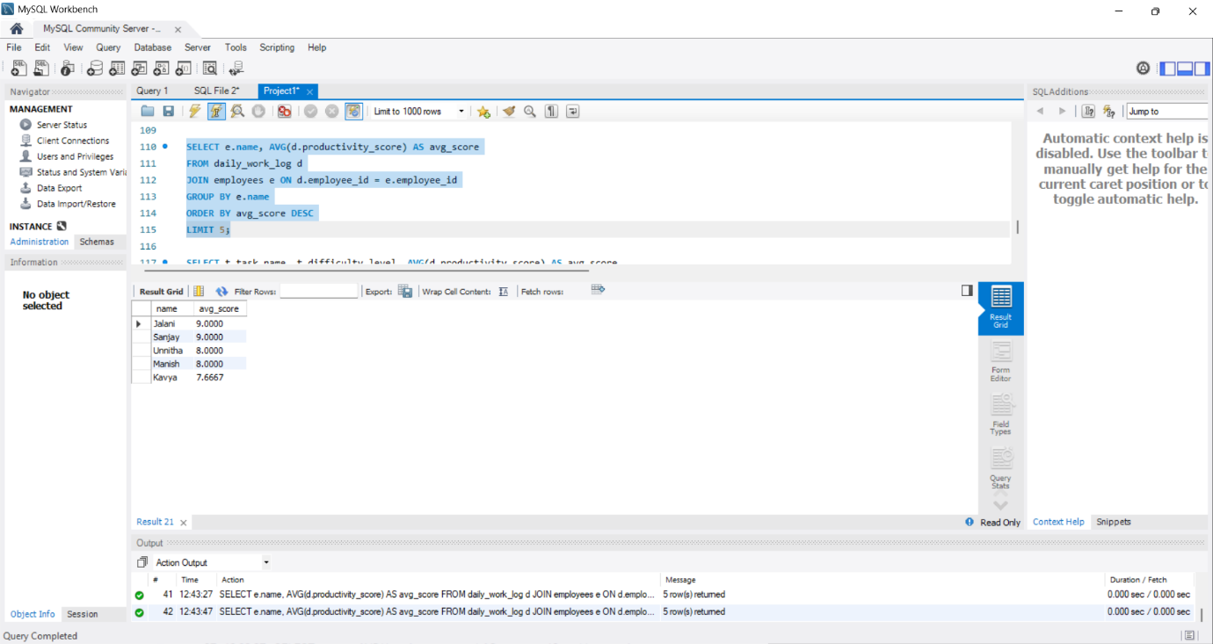
Figure8 - Employee names with their average scores
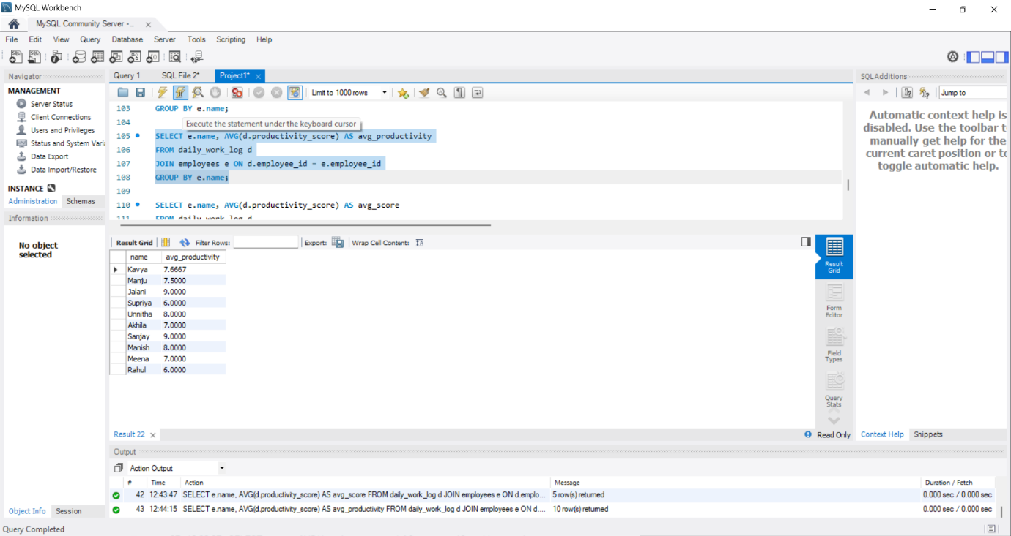
Figure9 - Table showing each employee’s name and average productivity
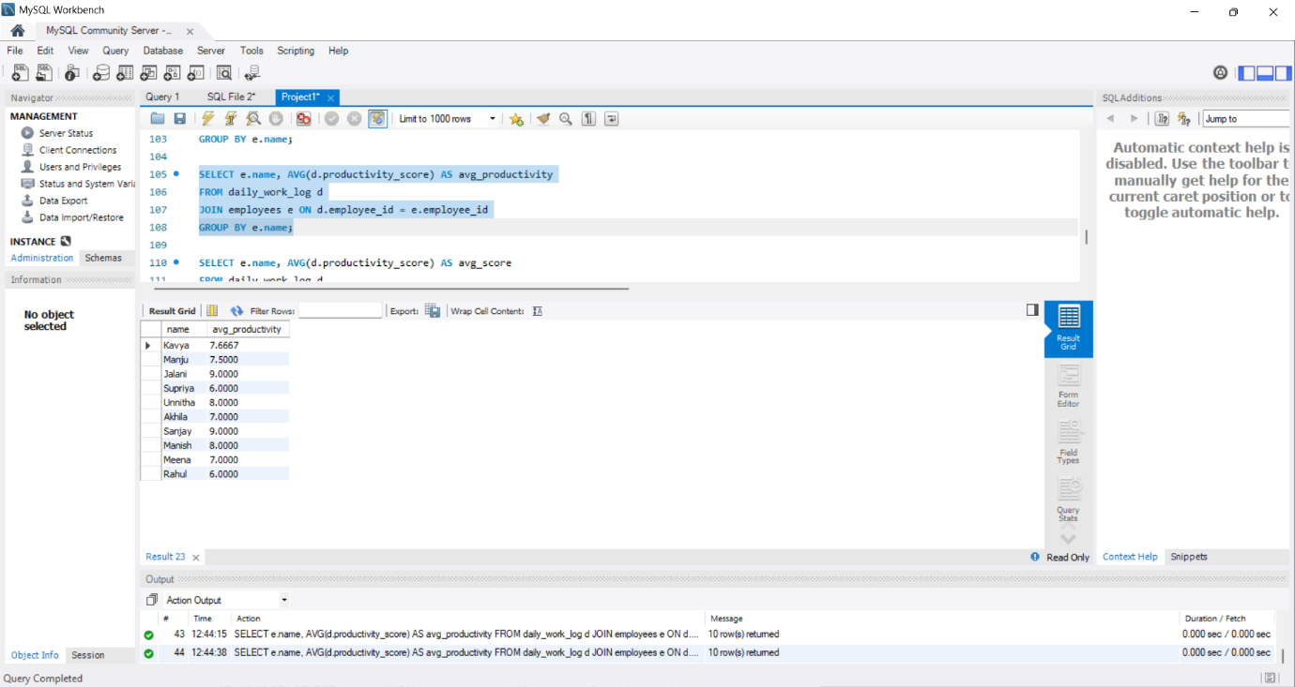
Figure10 - Summary of employee productivity performance
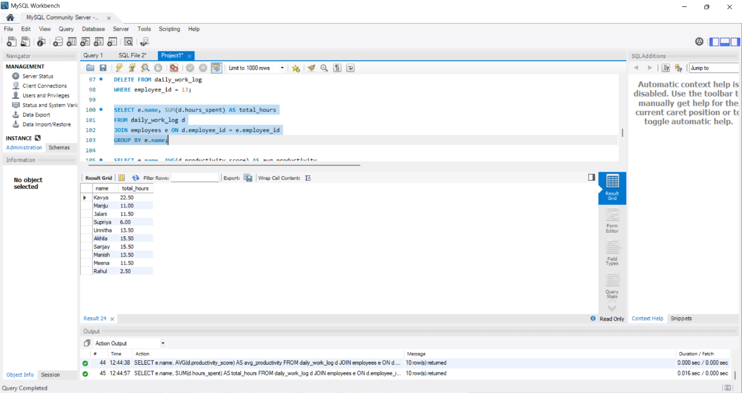
Figure11 - Table displaying each employee’s name and total hours spent on tasks

